Compass Design using Sensors User’s Guide

# **Introduction**

This guide is intended to help the user of this application navigate and user and for them to use all of the features optimally. It will provide information on the functionality available and how to achieve it. It will also list the requirements needed for the application to properly be installed. This application is aimed at uses who would like the ability to orientate themselves relative to the North pole whilst allow a picture to be taken with this orientation data included. It also displays the battery information to the user. This application is only for android phones.

# **Requirements**

There are requirements that your phone must have in order for the application to successfully run and use all of the features:

* 1. SDK Version: The SDK version must be 16 or greater in order to for the application to run. If the SDK version is below 23 then the user must manually grant the permissions listed in b.
  2. Permissions: In order to use the application permissions must be granted to the application. These include:
     1. Camera: Needed to take pictures.
     2. Storage: Needed to save the pictures to the device’s storage.
  3. Hardware: The device must contain the necessary sensors in order for the application to orientate and provide a picture:
     1. Rotation Vector: A sensor which is used to get the orientation of the device and thus an accelerometer and magnetometer is required. A gyroscope is optional but if it is in the device it will increase the accuracy of the orientation result.
     2. Camera: A sensor used to take a picture and requires a camera attached to the device.

# **Functionality**

The application provides 3 core pieces of functionality which the user can make use of:

1. Orientation Information: This is information relating to the bearing the device is pointing. There is also an image of a compass that will point North.
2. Capturing pictures: This allows the user to take a picture with the orientation information and time + date included in the filename. The location of these pictures are dependent on if external storage is present. If an SD card is attached then the location will be on the SD card under the folder “EMFdetectingApp”, if no SD card is present, then the location is in the gallery also under “EMFdetectingApp”.
3. Battery Information: This is information relating to the battery including: charge level, voltage, temperature, technology, status, charging type and health.

# **Interface and Navigation**

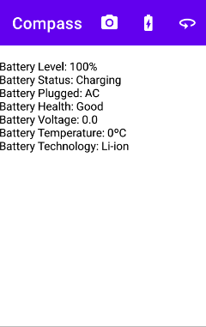

Screen 2: Battery Information

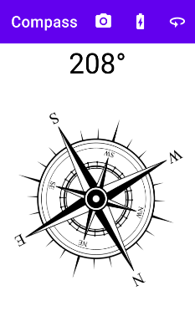

Screen 1: Compass

v

Present above are the two possible screens that can be seen when using the application. Screen 1 shows the compass, and this will point towards North even as you move the device. Above this compass image is the bearing show at 208 degrees, highlighted by the purple box. In the other screen the battery information is present highlighted by the green coloured box.

At the top of both screens there is a toolbar, which is highlighted in red. This contains the name of the application “Compass” and icons with allow the user to execute features:

1. Camera Icon: This is highlighted in the yellow/orange box and looks like a camera. When this is pressed the device will take a picture and provide the functionality describe in 3.b.
2. Battery Icon: This is highlighted in the light blue box and looks like a battery. When this is pressed the device will open the battery information screen (screen 2).
3. Orientation Icon: This is highlighted in the grey box and looks like a circular arrow. When this is pressed the device will open the compass screen (screen 1).

# **Problems and Solutions**

As with any application, problems may arise and as such a table is provided which references common issues, their symptoms and how to solve them.

|  |  |  |
| --- | --- | --- |
| Problem | Symptom | Solution |
| Sensor Inaccuracy | Orientation rapidly changing or being wrong | Move device in figure of 8 |
| Permissions not granted | The camera does not work and/or the picture does not save. | Grant permissions listed in section 2.b. |